Van Pruissen Asian Art: bringing people and art together
Art is more than just an object; it tells a story, creates a connection between maker and collector, and evokes emotion. Guided by this belief, Van Pruissen Asian Art brings people and art closer together. Under the motto “bringing people and art together,” we strive to make art accessible to a broad audience. In 2026, we will participate in the prestigious BRAFA Art Fair, where we look forward to introducing visitors to our vision and collection.

A Philosophy rooted in nature
Van Pruissen Asian Art was founded by Erwin van Pruissen, a passionate connoisseur of Asian art. His inspiration lies in the harmonious relationship between humans and nature. This idea forms the foundation of our work: we see ourselves as part of the natural world and believe that the five elements - wood, fire, earth, metal, and water - not only shape our existence but also reflect the essence of art.

The five elements: a source of inspiration and meaning
Our collection consists of carefully selected objects, each embodying one or more of these elements:
Wood symbolizes growth and vitality and is essential in Japanese netsuke, inro, and lacquerware. It provides the physical foundation for these objects while carrying a lively energy visible in the meticulously carved details. Fire represents passion and transformation, serving as the creative force behind ceramics and metalwork. The intense heat of fire transforms clay into lasting art and purifies metal into strong, refined forms. Earth conveys stability and connection and is literally present in ceramics and bronze sculptures, lending weight, texture, and a timeless, grounded presence. Metal stands for purity and structure, clearly expressed in tsuba and sword ornaments, where precision, strength, and refined craftsmanship reveal the essence of this element. Water embodies flow and emotion, reflected in painting, prints, and ceramics, and symbolizes movement, flexibility, and emotional depth. Recognizing these elements invites a deeper engagement with art—not just to look at it, but to truly feel it.

A carefully curated collection
At Van Pruissen Asian Art, each object is selected with expertise, attention to detail, and respect for its history. We travel the world in search of exceptional, authentic pieces that combine aesthetic beauty with story and meaning. From antique objects to contemporary sculptures, every work we present reflects craftsmanship and the cultural richness of East Asia.
Meet Van Pruissen Asian Art at the BRAFA Art Fair 2026
We warmly invite you to visit us at the BRAFA Art Fair. Discover how the philosophy of the five elements comes to life in our collection, be inspired by refined works of art, and experience how “bringing people and art together” drives everything we do.
Erwin & Anouk van Pruissen - Van Pruissen Asian Art – Stand No.018
Arnhem – The Netherlands | M: +31(0)649318660
E: Info@vanpruissen.art | www.vanpruissen.art
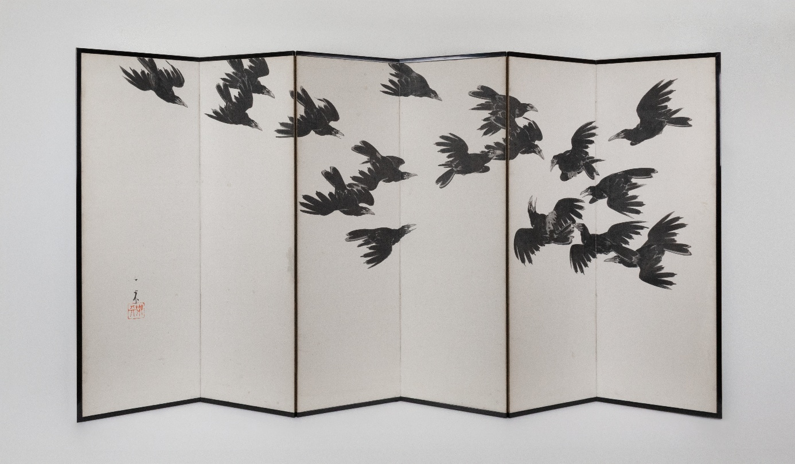
Nagai Ikka (Japan, 1869–1940)
Pair of six-panel folding screens with crows, 1930s
Ink on paper
H 137 x W 268 cm (each)
Signed in the bottom corner
Provenance: private collection, Japan
Price € 17.500,-

